P a g e | 1

Code Detection using MATLAB

MAJOR PROJECT REPORT

Submitted in partial fulfilment for award of degree of

Bachelor of Technology

In

Electronics and Communication

By

Harsimran Singh Bindra

(01076802813)

Harkirat Singh kambo

(02376802813)

Novjeet Singh

(02076802813)

Simranjeet Singh Bhatia

(03276802813)

To

Project Coordinators

Mr. Gurmeet Singh Ms. Chanpreet Kaur


Department of Electronics and Communication Engineering

Guru Tegh Bahadur Institute of Technology, Delhi

Batch: 2016-2017
P a g e | 2

DECLARATION

This is to certify that the project report entitled “Code detection using MATLAB”, which is submitted by us in partial fulfillment of the requirement for the award of B.Tech degree, in Electronics and Communication to Guru Tegh Bahadur Institute of Technology, Delhi comprises only our original work and due acknowledgement has been made in the test to all other material used.

Date: 21 November, 2016 Students Name

Harsimran Singh Bindra

(01076802813)

Harkirat Singh kambo

(02376802813)

Novjeet Singh

(02076802813)

Simranjeet Singh Bhatia

(03276802813)
P a g e | 3

CERTIFICATE

This is to certify that the project report entitled “CODE DTECTION USING MATLAB”, which is submitted by Harsimran Singh Bindra (01076802813), Harkirat Singh kambo(02376802813), Novjeet Singh (02076802813) and Simranjeet Singh(03276802813) in partial fulfillment of the requirement for the award of B.Tech degree, in Electronics and Communication to Guru Tegh Bahadur Institute of Technology, Guru Gobind Singh Indraprastha University, Delhi is a record of the candidate own work carried out by them under our supervision and guidance. The matter embodied in this thesis is original work and to the best of my knowledge and belief the material has not been submitted elsewhere for the award of any other degree.

Place:New Delhi

Date: 21 November, 2016

Mr. Mahender Singh Dr. S. Mukhopadhyay

(Mentor) (H.O.D)

Mr.Gurmeet Singh Ms. Chanpreet Kaur

(Project Coordinator) (Project Coordinator)
P a g e | 4

ACKNOWLEDGEMENT

Setting an endeavor may not always be an easy task; obstacles are bound to come in its way and when this happens, help is welcome and needless to say without help of those people whom we are mentioning here, this endeavor would not have been successful. We are very much thankful for the precious contribution of our guides Mr Gurmeet Singh and our coordinators Mr Gurmeet Singh and Ms Chanpreet Kaur who provided all their possible help. We would also like to thank our H.O.D. Mr S. Mukhopadhyay for his constant support and encouragement. The successful completion of this project has been possible due to sincere co-operation, guidance and timely advice from all the fore mentioned, who devoted their utmost co-operation in this project work.

Harsimran Singh Bindra (01076802813)

Harkirat Singh kambo (02376802813)

Novjeet Singh (02076802813)

Simranjeet Singh Bhatia (03276802813)
P a g e | 5

INDEX

S.NO. CHAPTERS PAGE NO.

1. INTRODUCTION 7

- Introduction

1.2 | Software used | 8
1.3 | Digital Modulation | 9
2. TYPES OF LINE CODING |  | 10
2.1 | Unipolar NRZ | 11
2.2 | Unipolar RZ
2.3 | Polar NRZ | 12
2.4 | Polar RZ | 22
2.5 | Manchester
2.6 | Bipolar

3. | DATA COMPRESSION TECHNIQUES | 30
4. | SOURCE CODE
5. | FUTURE SCOPE | 46
6. | REFERENCES

P a g e | 6

S.NO. | LIST OF FIGURES AND DIAGRAMS | PAGE NO.
1. | Voltage regulator (7805) | 9
2. | Accelerometer ( ADLX335) | 10
3. | PIC Microcontroller ( PIC16F887) | 11
4. | Architecture of PIC Microcontroller | 13
5. | Program Memory | 14
6. | Pin Description of PIC16F887 | 19
7. | RF Transmeter | 22
8. | RF module (Receiver and Transmeter) | 25
9. | RF Receiver | 28
10. | Circuit Diagram for Transmitter Section | 30
11. | Circuit Diagram for Receiver Section | 31
12. | Picture of Model (Receiver and Transmeter Side) | 32

P a g e | 7

CHAPTER-1

1.1 INTRODUCTION

In the existing system, human hand movements are sensed by the robot through sensors and it follow the same. As the person moves their hand, the accelerometer also moves accordingly sensor displaces and this sensor senses the parameter according to the position of hand. In this system, a gesture driven robotic vehicle is developed, in which the vehicle movements and manipulations ie, handling and control is depends on the gesture of the user. In this system, gesture is captured by accelerometer and it is processed by software namely, microcontroller software and the parameters are sent to microcontroller and encoder circuit, It is further transmitted (transmitter section) by RF433 MHZ transmitter. In the receiver section, the RF 433 MHZ receiver holds down the received parameters and process with microcontroller and gives those parameters to the robotic vehicle so that it act accordingly to the gesture. By this system, it is possible to achieve processing of long distance. This system is knowingly developed to apply in medical field for nursing assistance to physicians and in surgeries.

1.2 Mode of Project

In this we used Acceleromter. An accelerometer is an electro-mechanical device that will measure acceleration forces. These forces may be static, like the constant force of gravity pulling at your feet, or they could be dynamic – caused by moving or vibrating the accelerometer.

- Components

  - PIC Microcontroller(PIC16F887)
  - Accelerometer

  - L293-Motor driver

  - 7805 IC

  - Chesis

  - 2 Tyre

  - Pre wheel

  - Dc motor 60rpm

  - 2 PCB

  - Capacitor

  - Crystal oscillator

  - Register

1.4 Software used

- Proteus software(for circuit diagram)

- Mp lab IDE(for coding)

P a g e | 8

1.5 Circuit Diagram
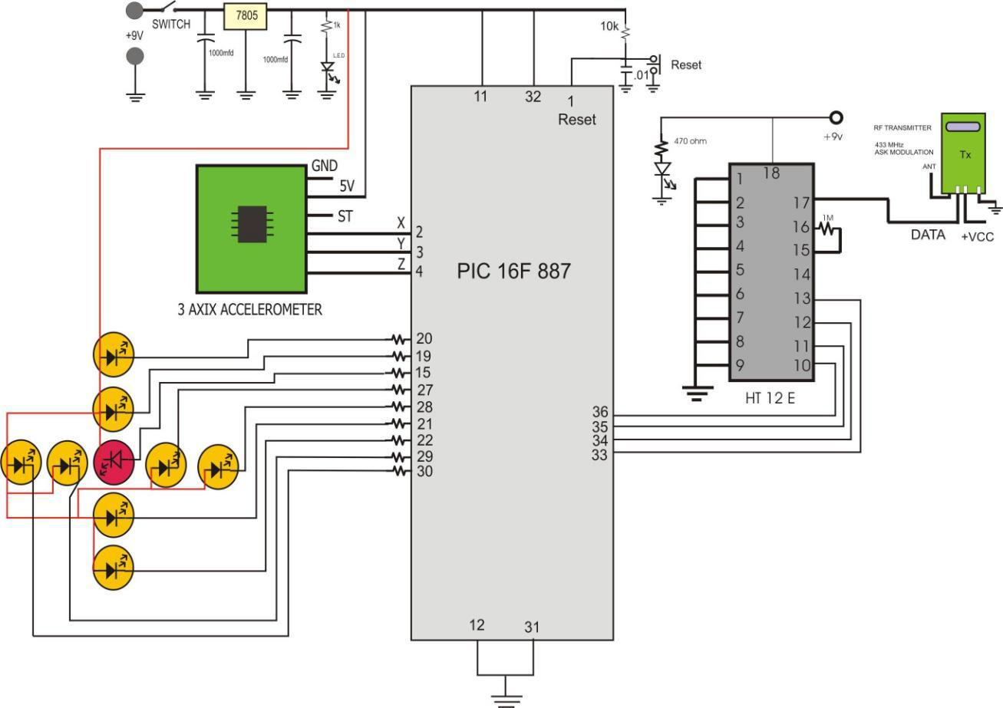

Fig.no-1.5
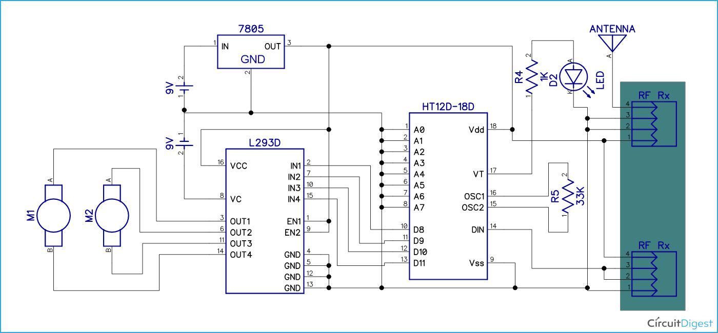
P a g e | 9

CHAPTER 2

HARDWARE DESCRIPTION

2.1 POWER SUPPLY:-

In the power supply section we have used a 9 volt dc battery. This is filtered by the capacitor. Capacitor converts the pulsating dc into smooth dc with the help of charging and discharging effect. Output of the capacitor is now regulated by the IC 7805(voltage regulator). IC 7805 provides a 5 volt regulation to the circuit and a regulated 5 volt power supply. Output of the regulator is now again filtered by the capacitor. In the output of the capacitor we use one resistor and one LED in series to provide a visual indication to the circuit.
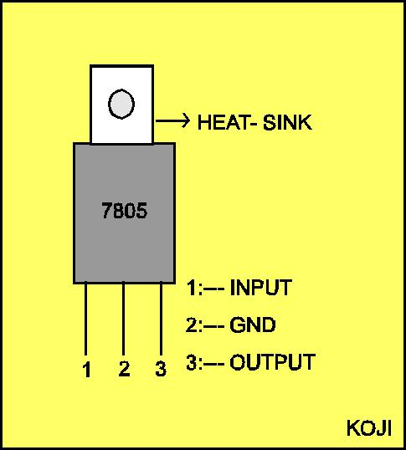

Fig.no-2.1(a)

An accelerometer is a device that measures the proper acceleration of the device. This is not necessarily the same as the coordinate acceleration (change of velocity of the device in space), but is rather the type of acceleration associated with the phenomenon of weight experienced by a test mass that resides in the frame of reference of the accelerometer device.
P a g e | 10

For an example of where these types of acceleration differ, an accelerometer will measure a value when sitting on the ground, because masses there have weights, even though they do not change velocity. However, an accelerometer in gravitational free fall toward the center of the Earth will measure a value of zero because, even though its speed is increasing, it is in an inertial frame of reference, in which it is weightless.

With the help of the accelerometer we can control the movement of any robotic arm or movement or control of any electrical appliances. If we install our accelerometer to our hand, then it is possible to control any thing with the help of our hand . So in our project we use accelerometer to control the direction of any robot . With the help of four different motion we control the direction of robot for forward, reverse left and right
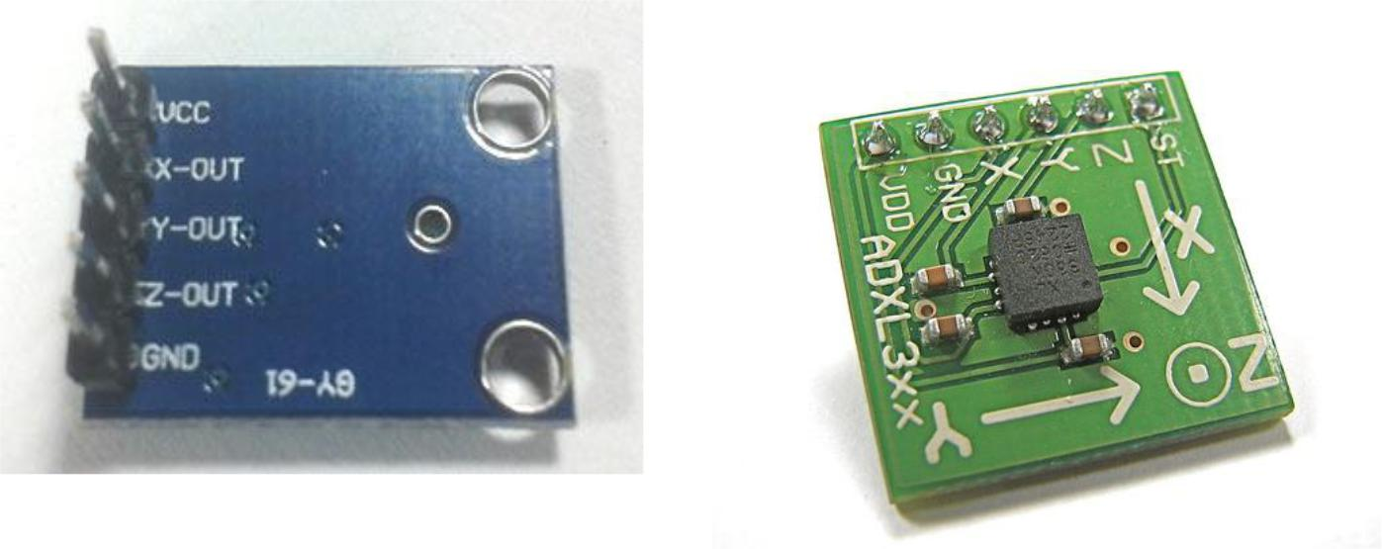

Fig.no-2.1(b)

Fig.no-2.1(c)

An accelerometer thus measures weight per unit of (test) mass, a quantity also known as specific force, or g-force. Another way of stating this is that by measuring weight, an accelerometer measures the acceleration of the free-fall reference frame (inertial reference frame) relative to itself.

Most accelerometers do not display the value they measure, but supply it to other devices. Real accelerometers also have practical limitations in how quickly they respond to changes in acceleration, and cannot respond to changes above a certain frequency of change.
P a g e | 11

2.1.1 Pin Description of accelerometer

1. Vcc 5 volt supply should connect at this pin.

- X-OUT This pin gives an Analog output in x direction

- Y-OUT This pin give an Analog Output in y direction

4. | Z-OUT | This pin gives an Analog Output in z direction
5. | GND | Ground
6. | ST | This pin used for set sensitivity of sensor

2.2 Basic connection circuit diagram of Accelerometer interfacing with PIC
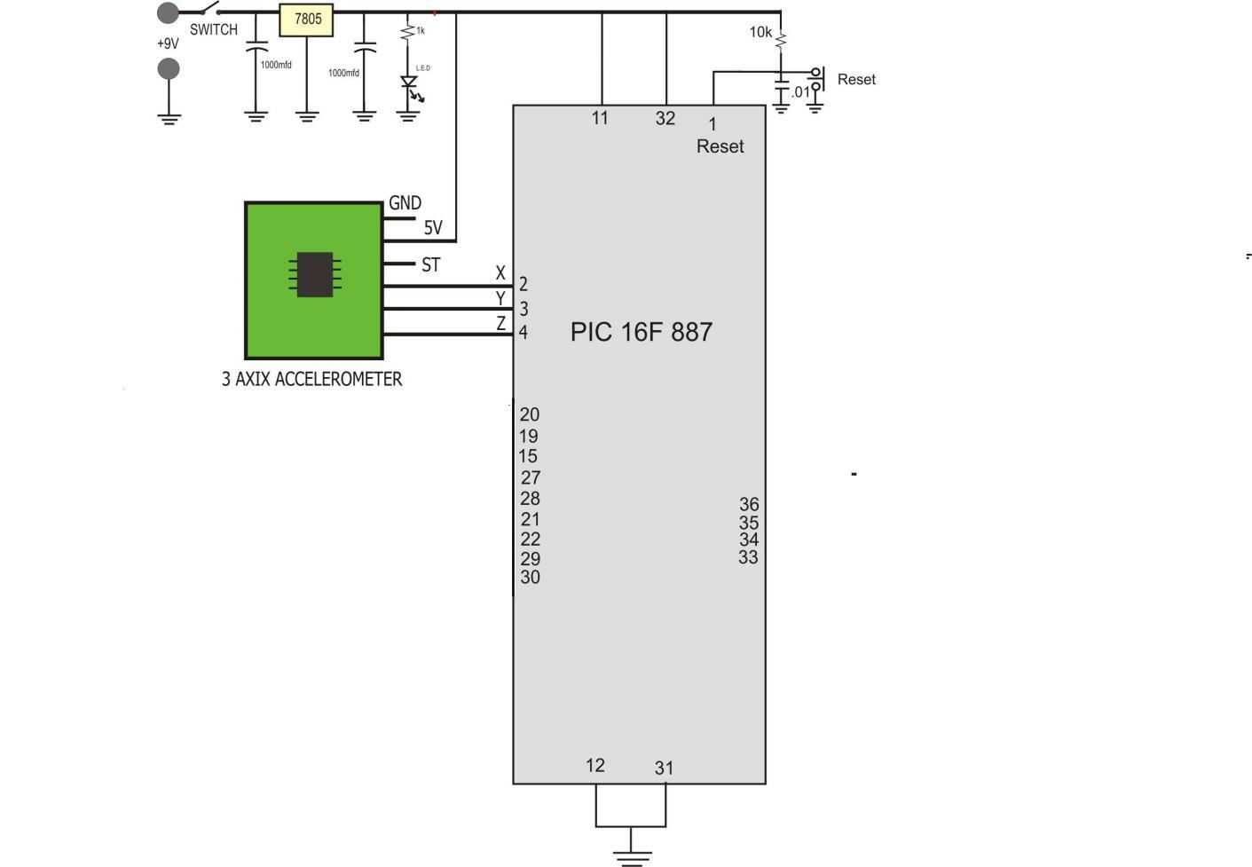

Fig,no-2.2

P a g e | 12

This Accelerometer module is based on the popular ADXL335 three-axis analog accelerometer IC, which reads off the X, Y and Z acceleration as analog voltages. By measuring the amount of acceleration due to gravity, an accelerometer can figure out the angle it is tilted at with respect to the earth. By sensing the amount of dynamic acceleration, the accelerometer can find out how fast and in what direction the device is moving. Using these two properties, you can make all sorts of cool projects, from musical instruments (imagine playing and having the tilt connected to the distortion level or the pitch-bend) to a velocity monitor on your car (or your children‟s car).

2.3 PIC MICROCONTROLLER:-

PIC microcontroller was developed by microchip technology. The term PIC stands for Peripheral Interface Controller. Initially this was developed for supporting PDP computers to control its peripheral devices, and therefore, named as a peripheral interface device. These microcontrollers are very fast and easy to execute a program compared with other microcontrollers. PIC Microcontroller architecture is based on Harvard architecture. PIC microcontrollers are very popular due to their ease of programming, wide availability, easy to interfacing with other peripherals, low cost, large user base and serial programming capability (reprogramming with flash memory), etc.

2.3.1 What is a PIC Microcontroller?

PIC (Programmable Interface Controllers) microcontrollers are the worlds smallest microcontrollers that can be programmed to carry out a huge range of tasks. These microcontrollers are found in many electronic devices such as phones, computer control systems, alarm systems, embedded systems, etc.

Every PIC microcontroller architecture consists of some registers and stack where registers function as Random Access Memory( RAM) and stack saves the return addresses. The main features of PIC microcontrollers are RAM, flash memory, Timers/Counters, EEPROM, I/O Ports, USART, CCP (Capture/Compare/PWM module), SSP, Comparator, ADC (analog to digital converter),LCD and ICSP (in circuit serial programming) .
P a g e | 13

2.3.2 Architecture of PIC Microcontroller

The PIC microcontroller architecture comprises of CPU, I/O ports, memory organization, A/D converter, timers/counters, interrupts, serial communication, oscillator and CCP module which are discussed in detailed below.
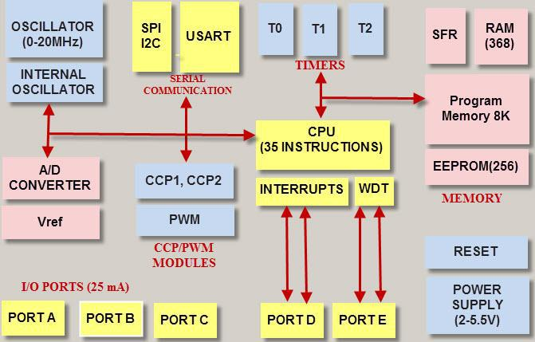

Architecture of PIC Microcontroller

CPU (CENTRAL PROCESSING UNIT)

It is not different from other microcontrollers CPU and the PIC microcontroller CPU consists of the ALU, CU, MU and accumulator, etc. Arithmetic logic unit is mainly used for arithmetic operations and to take logical decisions. Memory is used for storing the instructions after processing. To control the internal and external peripherals, control unit is used which are connected to the CPU and the accumulator is used for storing the results and further process.
P a g e | 14

2.4. MEMORY ORGANIZATION

MEMORY

This microcontroller has three types of memory- ROM, RAM and EEPROM. All of them will be separately discussed since each has specific functions, features and organization.

2.4.1. RANDOM ACCESS MEMORY (RAM)

RAM is an unstable memory which is used to store the data temporarily in its registers. The RAM memory is classified into two banks, and each bank consists of so many registers. The RAM registers are classified into two types: Special Function Registers (SFR) and General Purpose Registers (GPR).

- GENERAL PURPOSE REGISTERS (GPR)

These registers are used for general purpose only as the name implies. For example, if we want to multiply two numbers by using the PIC microcontroller. Generally, we use registers for multiplying and storing the numbers in other registers. So these registers don‟t have any special function,- CPU can easily access the data in the registers.

- SPECIAL FUNCTION REGISTERS

These registers are used for special purposes only as the name SFR implies. These registers will perform according to the functions assigned to them , and they cannot be used as normal registers.
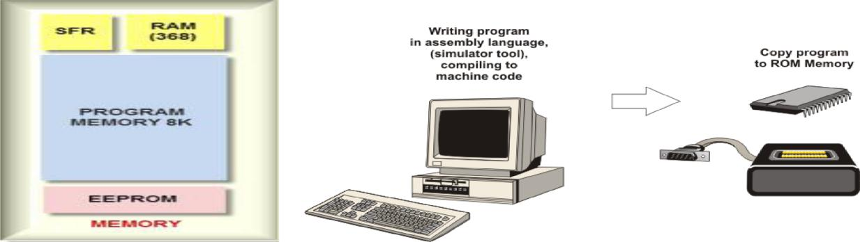
P a g e | 15

2.4.2. READ ONLY MEMORY (ROM)

Read only memory is a stable memory which is used to store the data permanently. In PIC microcontroller architecture, the architecture ROM stores the instructions or program, according to the program the microcontroller acts. The ROM is also called as program memory, wherein the user will write the program for microcontroller and saves it permanently, and finally the program is executed by the CPU. The microcontrollers performance depends on the instruction, which is executed by the CPU.

2.5. ELECTRICALLY ERASABLE PROGRAMMABLE READ ONLY

MEMORY (EEPROM)

In the normal ROM, we can write the program for only once we cannot use again the microcontroller for multiple times. But, in the EEPROM, we can program the ROM multiple times.

- I/O PORTS

  - The series of PIC16 consists of five ports such as Port A, Port B, Port C, Port D & Port E.

  - Port A is an 16-bit port that can be used as input or output port based on the status of the TRISA register.

  - Port B is an 8- bit port that can be used as both input and output port.

  - Port C is an 8-bit and the input of output operation is decided by the status of the TRISC register.

  - Port D is an 8-bit port acts as a slave port for connection to the microprocessor BUS.

  - Port E is a 3-bit port which serves the additional function of the control signals to the analog to digital converter.
P a g e | 16

2.7. BUS

BUS is used to transfer and receive the data from one peripheral to another. It is classified into two types such as data bus and address.

- Data Bus: It is used for only transfer or receive the data.

- Address Bus: Address bus is used to transmit the memory address from the peripherals to the CPU. I/O pins are used to interface the external peripherals; UART and USART both are serial communication protocols which are used for interfacing serial devices like GSM, GPS, Bluetooth, IR , etc.

2.8. A/D CONVERTERS

The main intention of this analog to digital converter is to convert analog voltage values to digital voltage values. A/D module of PIC microcontroller consists of 5 inputs for 28 pin devices and 8 inputs for 40 pin devices. The operation of the analog to digital converter is controlled by ADCON0 and ADCON1 special registers.

2.9. TIMERS/ COUNTERS

PIC microcontroller has three timer/counters wherein the one 8-bit timer and the remaining timers have the choice to select 8 or 16-bit mode. Timers are used for generating accuracy actions, for example, creating specific time delays between two operations.

2.10. INTERRUPTS

PIC microcontroller consists of 20 internal interrupts and three external interrupt sources which are associated with different peripherals like ADC, USART, Timers, and so on.
P a g e | 17

2.11. CCP MODULE

The name CCP module stands for capture/compare/PWM where it works in three modes such as capture mode, compare mode and PWM mode.

- Capture Mode: Capture mode captures the time of arrival of a signal, or in other words, when the CCP pin goes high, it captures the value of the Timer1.

- Compare Mode: Compare mode acts as an analog comparator. When the timer1 value reaches a certain reference value, then it generates an output.

- PWM Mode: PWM mode provides pulse width modulated output with a 10-bit resolution and programmable duty cycle.
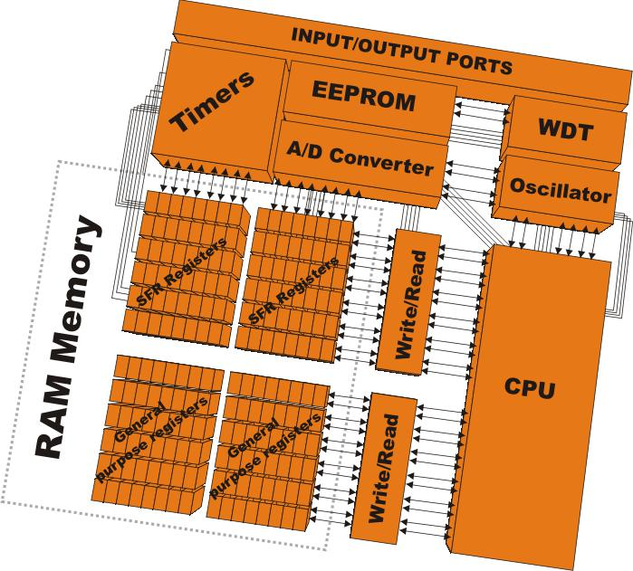
P a g e | 18

2.12. PIC MICROCONTROLLER APPLICATIONS

The PIC microcontroller projects can be used in different applications, such as peripherals, audio accessories, video games, etc

ADVANTAGES OF PIC MICROCONTROLLER:

- PIC microcontrollers are consistent and faulty of PIC percentage is very less. The performance of the PIC microcontroller is very fast because of using RISC architecture.

- When comparing to other microcontrollers, power consumption is very less and programming is also very easy.

- Interfacing of an analog device is easy without any extra circuitry

DISADVANTAGES OF PIC MICROCONTROLLER:

- The length of the program is high due to using RISC architecture (35 instructions)

- One single accumulator is present and program memory is not accessible
P a g e | 19

2.13. PIN DESCRIPTION OF PIC16F887
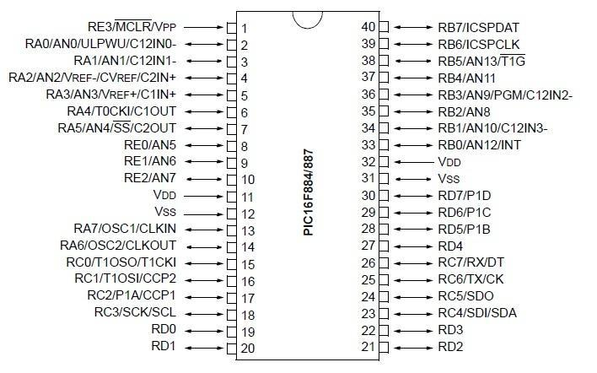

2.13.1. Input/Output ports

PIC16F877 has 5 basic input/output ports. They are usually denoted by PORT A (R A), PORT B (RB), PORT C (RC), PORT D (RD), and PORT E (RE).

These ports are used for input/ output interfacing. In this controller, “PORT A” is only 6 bits wide (RA-0 to RA-7), ”PORT B” , “PORT C”,”PORT D” are only 8 bits wide (RB-0 to RB-7,RC-0 to RC-7,RD-0 to RD-7), ”PORT E” has only 3 bit wide (RE-0 to RE-7).

PORT-A | RA-0 to RA-5 | 6 bit wide
PORT-B | RB-0 to RB-7 | 8 bit wide
PORT-C | RC-0 to RC-7 | 8 bit wide
PORT-D | RD-0 to RD-7 | 8 bit wide
PORT-E | RE-0 to RE-2 | 3 bit wid

P a g e | 20

All these ports are bi-directional. The direction of the port is controlled by using TRIS(X) registers (TRIS A used to set the direction of PORT-A, TRIS B used to set the direction for PORT-B, etc.). Setting a TRIS(X) bit „1‟ will set the corresponding PORT(X) bit as input. Clearing a TRIS(X) bit „0‟ will set the corresponding PORT(X) bit as output.

(If we want to set PORT A as an input, just set TRIS(A) bit to logical „1‟ and want to set

PORT B as an output, just set the PORT B bits to logical „0‟.)

- Analog input port (AN0 TO AN7) : these ports are used for interfacing analog inputs.

- TX and RX: These are the USART transmission and reception ports.

- SCK: these pins are used for giving synchronous serial clock input.

- OSC1: oscillator input/external clock.

- OSC2: oscillator output/clock out.

- MCLR: master clear pin (Active low reset).

- Vpp: programming voltage input.

- THV: High voltage test mode controlling.

- Vref (+/-): reference voltage.

- INT: external interrupt.

- RD: Read control for parallel slave port.

- CS: Select control for parallel slave.

- VDD: positive supply for logic and input pins.

- VSS: Ground reference for logic and input/output pins.

In this project we use 3 Axix accelerometer sensor to wireless control the wheel chair. In this project we use PIC 16F 887 IC to control all inputs and output related to the project.. We use 9 volt dc battery for this project. 9 volt dc is further converted into 5 volt dc with the help of 7805 regulator ic. Along with regulator IC we use two capacitor as a filter components. Output of the regulator is connected to power indicator l.e.d and at the same time to pin no 11,32 of the microcontroller. Pin no 11,32 is positive supply pin of the IC. Pin no 1 is connected to external RC circuit to provide a automatic reset in power on . We provide a manual reset also on pin no 1 by push to on switch. Pin no 12 and 31 is connected to the ground pin.
P a g e | 21

3 Axix accelerometer having a 6 pins. From right to left ist pin connected to ground. Second pin connected to positive 5 volt supply. 3rd pin is ST pin. We are not using this pin in our project. Output from 3 axix accelerometer is connected to the pin no 2,3,4 of the IC. Pin no 2,3,4 is analogue input pin of the IC. We getting a small voltage on these pins and data on these pins are further converted into digital with the help of A to D converted inside..

In this project we 8 l.e.d to identify the tilt position of the sensor. As we angle the sensor plate then l.e.d is also on. When 3 axix plate is straight then Only red led is on. When we angle the plate from centre to right or centre to left, up, back, then l.e.d pattern is also move. Actually when we vary the 3 axix then we measure the value of x,y,z and compare these vale with the pre recorded data inside. We get the data of 9 position. If the data is match with the particular data then only l.e.d is on..

When l.e.d is on then wheel chair is stop at that time. When last l.e.d is on then data is to be transmit from circuit. For data transmission we use RF transmitter and Receiver circuit, For Rf transmitter and Receiver circuit we use 433 Mhtz module . along with this module we use one encoder and decoder circuit to convert the parallel data in to serial data. Here we use HT 12 E encoder IC For convert parallel data into serial. By using this encoder we send a 8 bit address also. If the same address is match with the receiver circuit then data is transfer. Output from encoder is taken from pin no 17. Output from pin no 17 is connected to the input of the transmitter module. Transmitter module modulate the data on 433 Mhtz and transmit the same on the air.

At the receiver end we use Decoder IC to decode the data. Signal from transmitter side is received by the 433 Mhtz receiver and this data is further connected to the Decoder IC. Output of the Decoder is taken from pin no 10,11,12,13 and connected to the two motor base driver circuit. For driving motor we use Two H bridge circuit. With the help of this H bridge circuit we control the direction of DC-motor. We use four Opto-coupler IC to drive the two H bridge circuit. Output of the Decoder circuit is connected to the opto-coupler for optical isolation. With the help of this optical isolation we provide a isolation between two power supply. One supply for the Motor circuit and one supply for the decoder circuit. Output of the Opto-coupler is connected to the base of H bridge circuit. In this H bridge circuit we use four transistor base driver circuit. In this driver circuit we use two NPN and two PNP transistor
P a g e | 22

2.13.2. TRANSMITTER AND RECEIVER:-

Gesture Controlled Robot is divided into two sections:

- Transmitter part

- Receiver part

In transmitter part an accelerometer and a RF transmitter unit is used. As we have already discussed that accelerometer gives an analog output so here we need to convert this analog data in to digital. For this purpose we have used 4 channel comparator circuit in place of any ADC. By setting reference voltage we gets a digital signal and then apply this signal to HT12E encoder to encode data or converting it into serial form and then send this data by using RF transmitter into the environment.

In the transmitter circuit we use one RF module to send the data serially via radio frequency

. Here in this project we use 433 Mhtz radio frequency module o send the data serially. Modulating frequency of the project is 433Mhtz and modulation type is ASK.
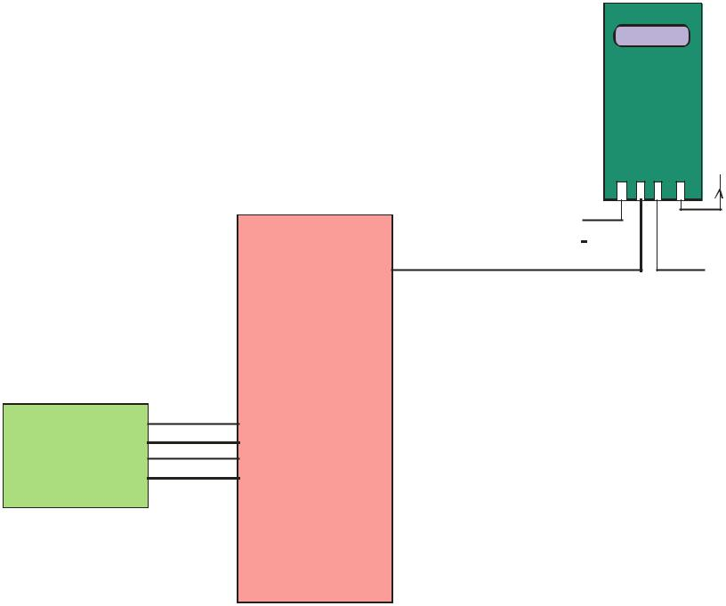

RF TRANSMITTER

433 MHtz
ASK MODULATION

ANT
GND
+VCC

DATA

ENCODER

DATA

When ever we want to send a data we use encoder ic to convert the parallel data into serial. This serial data is transmitting by the radio frequency module in air. For selecting a data base

P a g e | 23

we use DIP switches. In actual practice we use internal data base. But in this project we use external data base to selection. Here we use four bit data with the help of DIP switches. Data is to be converted into serial with the help of the encoder IC. Here we use HT 12E encoder IC. HT12E encoder IC convert the parallel data into serial data.
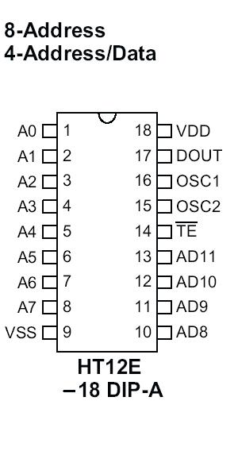

Pin no 1 to 8 is address pin. Pin no 9 is ground pin. Pin no 10,11,12,13 is data insertion pin. We provide a 0 bit on the entire address pin. But it is not necessary. We select the address line pins as our requirement. For providing a data to data pins either we provide a 4 bit data from microcontroller or any other digital circuit or we connect DIP switches Dip switches are connected with the pin no 10,11,12,13 . Pin no 14 is transmit control pin. We control the pin no 14 by connecting a pin no 14 to ground pin. When this pin is ground then only, data is to be transmit from the IC . Pin no 15 and 16 is the oscillator pin of the encoder IC . On this pin we connect a 1 M ohm resistor. Pin no 17 is data output pin. Data from this pin is connected to the input of transmitter module.

Data receive by the radio frequency receiver module. This receiver module is same as the frequency of transmitter module. Output from radio frequency module is further decoded by the decoder IC. Output of the decoder IC is further converted into parallel and proceeds to the microcontroller for further process. Or we get the data from decoder directly

At the receiver end we have used RF receiver to receive data and then applied to HT12D decoder. This decoder IC converts received serial data to parallel and then read by using arduino. According to received data we drive robot by using two DC motor in forward, reverse, left, right and stop direction.
P a g e | 24
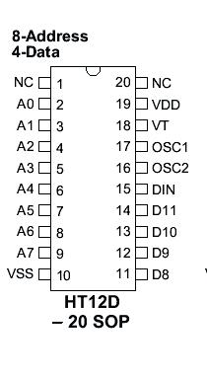

Working

Gesture controlled robot moves according to hand movement as we place transmitter in our hand. When we tilt hand in front side, robot start to moving forward and continues moving forward until next command is given.

When we tilt hand in backward side, robot change its state and start moving in backwards direction until other command is given.

When we tilt it in left side Robot get turn left till next command.

When we tilt hand in right side robot turned to right.

And for stopping robot we keeps hand in stable.
P a g e | 25

2.14. RECEIVER AND TRANSMITTER
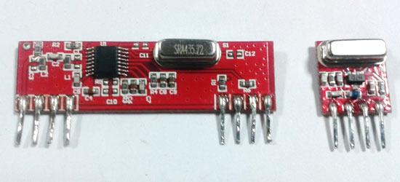

The RF module, as the name suggests, operates at Radio Frequency. The corresponding frequency range varies between 30 kHz & 300 GHz. In this RF system, the digital data is represented as variations in the amplitude of carrier wave. This kind of modulation is known as Amplitude Shift Keying (ASK).

Transmission through RF is better than IR (infrared) because of many reasons. Firstly, signals through RF can travel through larger distances making it suitable for long range applications. Also, while IR mostly operates in line-of-sight mode, RF signals can travel even when there is an obstruction between transmitter & receiver. Next, RF transmission is more strong and reliable than IR transmission. RF communication uses a specific frequency unlike IR signals which are affected by other IR emitting sources.

This RF module comprises of an RF Transmitter and an RF Receiver. The transmitter/receiver (Tx/Rx) pair operates at a frequency of 434 MHz. An RF transmitter receives serial data and transmits it wirelessly through RF through its antenna connected at pin4. The transmission occurs at the rate of 1Kbps - 10Kbps.The transmitted data is received by an RF receiver operating at the same frequency as that of the transmitter.
P a g e | 26

The RF module is often used alongwith a pair of encoder/decoder. The encoder is used for encoding parallel data for transmission feed while reception is decoded by a decoder. HT12E-HT12D, HT640-HT648, etc. are some commonly used encoder/decoder pair ICs.

2.14.1. Pin Diagram:
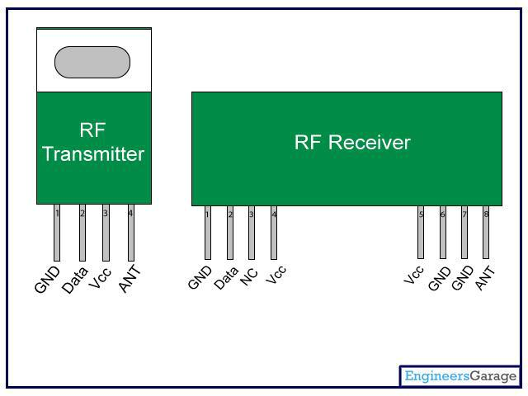
 |  |  | P a g e | 27
 | • Pin Description:
 |  | (a) RF Transmitter
 | Pin No | Function | Name
 | 1 | Ground (0V) | Ground
 | 2 | Serial data input pin | Data
 | 3 | Supply voltage; 5V | Vcc
 | 4 | Antenna output pin | ANT
 |  | (b) RF Receiver
 | Pin No | Function | Name
 | 1 | Ground (0V) | Ground
 | 2 | Serial data output pin | Data
 | 3 | Linear output pin; not connected | NC
 | 4 | Supply voltage; 5V | Vcc
 | 5 | Supply voltage; 5V | Vcc
 | 6 | Ground (0V) | Ground
 | 7 | Ground (0V) | Ground
 | 8 | Antenna input pin | ANT

P a g e | 28
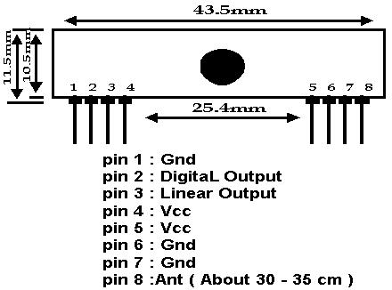

The TWS-434 and RWS-434 are extremely small, and are excellent for applications requiring short-range RF remote controls. The transmitter module is only 1/3 the size of a standard postage stamp, and can easily be placed inside a small plastic enclosure.

TWS-434: The transmitter output is up approximately 400 foot (open area) outdoors. and will go through most walls.
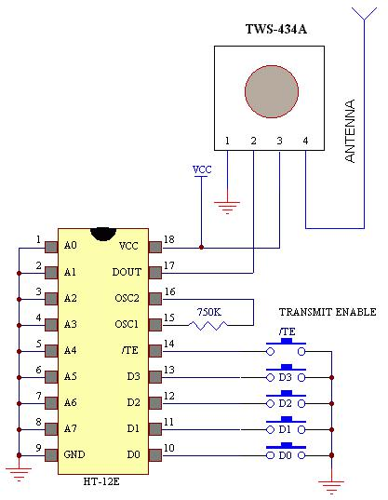
to 8mW at 433.92MHz with a range of Indoors, the range is approximately 200 foot,

Sample TRANSMITTER Application Circuit

P a g e | 29

The TWS-434 transmitter accepts both linear and digital inputs, can operate from 1.5 to 12 Volts-DC, and makes building a miniature hand-held RF transmitter very easy. The TWS-434 is approximately the size of a standard postage stamp.

RWS-434: The receiver also operates at 433.92MHz, and has a sensitivity of 3uV. The RWS-434 receiver operates from 4.5 to 5.5 volts-DC, and has both linear and digital outputs.
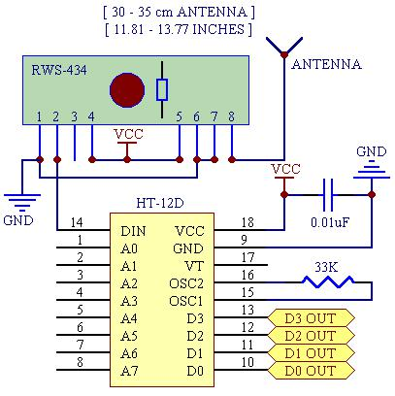

Sample Receiver Application Circuit

The example above shows the receiver section using the HT-12D decoder IC for a 4-bit RF remote control system. The transmitter and receiver can also use the Holtek 8-bit HT-640/HT-648L remote control encoder/decoder combination for an 8-bit RF remote control system. Here are the schematics for an 8-bit RF remote control system:
P a g e | 30

CHAPTER 3

3.1. CIRCUIT DIAGRAM OF COMPLETE HARDWARE

Circuit Diagram for Transmitter Section
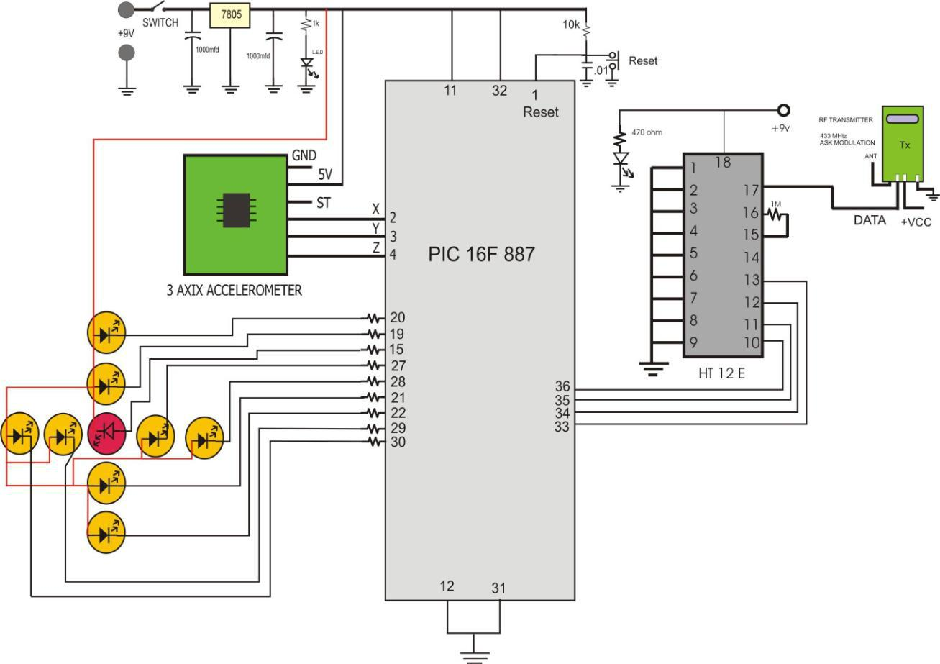
P a g e | 31

3.2. Circuit Diagram for Receiver Section

Fig.no-3.2(a)
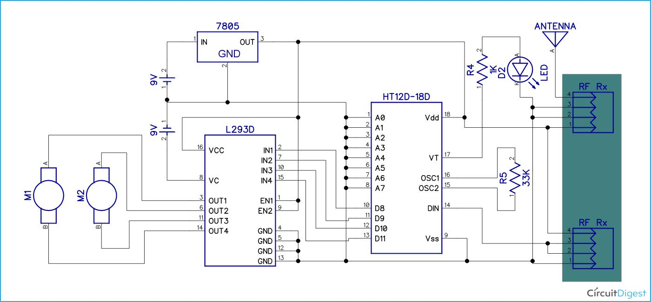

Fig.no-3.2(b)
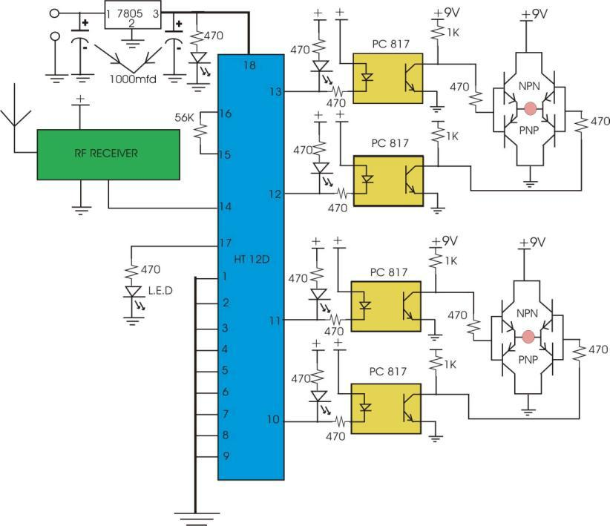
P a g e | 32
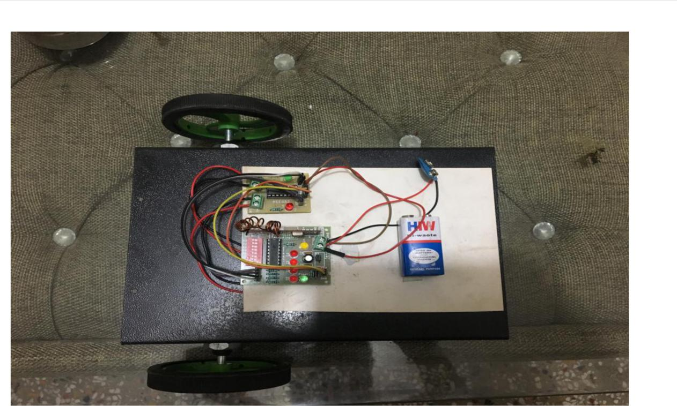

Fig.no-(c) RECEIVER SIDE
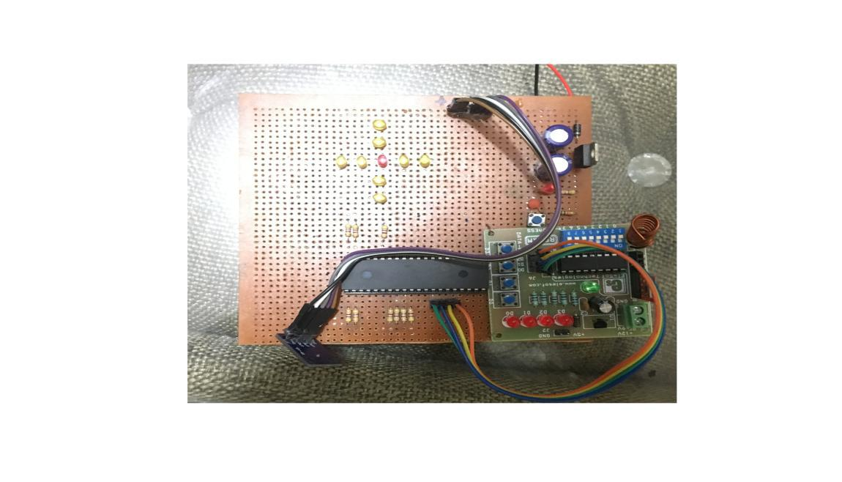

Fig.no-(d) TRANSMITTER SIDE
P a g e | 33

3.3. There are total five conditions for this Gesture controlled Robot which

are giving below:

Movement | of | Input for PIC from gesture
hand
Side |  | D3 | D2 | D1 | D0 | Direction
Stable |  | 0 | 0 | 0 | 0 | Stop
Tilt right |  | 0 | 0 | 0 | 1 | Turn Right
Tilt left |  | 0 | 0 | 1 | 0 | Turn Left
Tilt back |  | 1 | 0 | 0 | 0 | Backward
Tilt front |  | 0 | 1 | 0 | 0 | Forward

P a g e | 34

CHAPTER-4

APPENDIX (A)

4.1. CODE:

#define X1 RD0 #define X2 RD1 #define X3 RD2 #define X4 RD3

#define Y1 RD4 #define Y2 RD5 #define Y3 RD6 #define Y4 RD7

#define m1_1 RB0 #define m1_2 RB1

#define m2_1 RB2 #define m2_2 RB3

#define lcd PORTB #define rs RD7 #define en RD6

void delay(unsigned long int a)

{

while(a-);

}

void main()
 | P a g e | 35
{
OSCCON=0x60;
 | CM2CON0=0X00;
CM1CON0=0x00; | //pins are not for analog
comparator that is comperator mode is off
TRISB=0x00;
TRISD=0x00; | //ra3 is input and all other pins are out
put for relay and ra3 used for ir protocol
TRISC=0X00; | //portc has all out put pins
INTCON=0X00; | //all maskable interrupt are
disable

//IOCA=0X00; //all mode is disable

IOCB=0x00;

ANSELH=0x00;

ANSEL=0X03; //all pins are behave like digital

pins

CM2CON0=0X07;

CM1CON0=0x07; //comperator mode is off

PORTA=0X03; //intially device is off

PORTB=0X00; //initially all device is off

TRISA=0X03;

P a g e | 36

ANSEL=0X03;

ANSELH=0X00;

RC0=1;

PORTD=0xff;

m1_1=1;

m1_2=1;

m2_1=1;

m2_2=1;

while(1)

{

unsigned int xaxis,yaxis;

ADCON0=0X05;

ADCON1=0X80;

GO=1;

while(GO==1);

delay(1000);

ADCON0=0X01;

ADCON1=0X80;

GO=1;

while(GO==1);

delay(1000);

if(xaxis<35&&xaxis>30&&yaxis<351&&yaxis>30)

{
P a g e | 37

X1=1;

X2=1;

Y1=1;Y2=1; center=0; Y3=1;Y4=1;

X3=1;

X4=1;

m1_1=1;

m1_2=1;

m2_1=1;

m2_2=1;

}

else if(xaxis<36&&xaxis>35&&yaxis<35&&yaxis>30)

{

X1=1;

X2=0;

Y1=1;Y2=1; center=0; Y3=1;Y4=1;

X3=1;

X4=1;

m1_1=1;

m1_2=1;

m2_1=1;

m2_2=1;

}

else if(xaxis>36&&yaxis<31&&yaxis>30)

{

X1=0;

X2=0;

Y1=1;Y2=1; center=1; Y3=1;Y4=1;
P a g e | 38

X3=1;

X4=1;

m1_1=1;

m1_2=0;

m2_1=1;

m2_2=0;

}

else if(xaxis<30&&xaxis>20&&yaxis<31&&yaxis>300)

{

X1=1;

X2=1;

Y1=1;Y2=1; center=0; Y3=1;Y4=1;

X3=0;

X4=1;

m1_1=1;

m1_2=1;

m2_1=1;

m2_2=1;

}

else if(xaxis<290&&yaxis<351&&yaxis>300)

{

X1=1;

X2=1;

Y1=1;Y2=1; center=1; Y3=1;Y4=1;

X3=0;

X4=0;

m1_1=0;

m1_2=1;
P a g e | 39

m2_1=0;

m2_2=1;

}

else if(yaxis<366&&yaxis>351&&xaxis<351&&xaxis>300)

{

X1=1;

X2=1;

Y1=1;Y2=0; center=0; Y3=1;Y4=1;

X3=1;

X4=1;

m1_1=1;

m1_2=1;

m2_1=1;

m2_2=1;

}

else if(yaxis>366&&xaxis<351&&xaxis>300)

{

}

else if(yaxis<300&&yaxis>290&&xaxis<351&&xaxis>300)

{

X4=1;

m2_2=1;

}

else if(yaxis<290&&xaxis<351&&xaxis>300)

{
P a g e | 40

X1=1;

X2=1;

Y1=1;Y2=1; center=1; Y3=0;Y4=0;

X3=1;

X4=1;

m1_1=0;

m1_2=1;

m2_1=1;

m2_2=0;

}

else if(xaxis<366&&xaxis>351)

{

if(yaxis<366&&yaxis>351)

{

X1=1;

X2=0;

else if(yaxis>366)

{

X1=1;

X2=0;

}

else if(yaxis<300&&yaxis>290)

{

X1=1;

X2=0;

}

else if(yaxis<290)

{
P a g e | 41

X1=1;

X2=0;

Y1=1;Y2=1; center=0; Y3=0;Y4=0;

X3=1;

X4=1;

}

}

else if(xaxis>366)

{

m2_2=1;

if(yaxis<366&&yaxis>351)

{

X1=0;

X2=0;

Y1=1;Y2=0; center=0; Y3=1;Y4=1;

X3=1;

X4=1;

}

else if(yaxis>366)

{

X1=0;

X2=0;

Y1=0;Y2=0; center=0; Y3=1;Y4=1;

}

else if(yaxis<30&&yaxis>20)

{

X1=0;

P a g e | 42

X2=0;

}

else if(yaxis<290)

{

X1=0;

X2=0;

}

}

else if(xaxis<30&&xaxis>90)

{

m1_1=1;

m1_2=1;

m2_1=1;

m2_2=1;

if(yaxis<36&&yaxis>31)

{

X1=1;

X2=1;

Y1=1;Y2=0; center=0; Y3=1;Y4=1;

X3=0;

X4=1;

}

else if(yaxis>66)

{

X1=1;

X2=1;
P a g e | 43

else if(yaxis<30&&yaxis>20)

{

X1=1;

X2=1;

}

else if(yaxis<20)

{

X1=1;

X2=1;

}

}

else if(xaxis<20)

{

m1_1=1;

m1_2=1;

m2_1=1;

m2_2=1;

if(yaxis<36&&yaxis>31)

{

X1=1;

X2=1;

Y1=1;Y2=0; center=0; Y3=1;Y4=1;

X3=0;

X4=0;

}

else if(yaxis>366)

{

X1=1;

X2=1;
P a g e | 44

Y1=0;Y2=0; center=0; Y3=1;Y4=1;

X3=0;

X4=0;

}

else if(yaxis<300&&yaxis>290)

{

X1=1;

X2=1;

Y1=1;Y2=1; center=0; Y3=0;Y4=1;

X3=0;

X4=0;

}

else if(yaxis<290)

{

X1=1;

X2=1;

Y1=1;Y2=1; center=0; Y3=0;Y4=0;

X3=0;

X4=0;

}

}

}

}
P a g e | 45

APPENDIX (B)

4.2. ADXL335 Specification
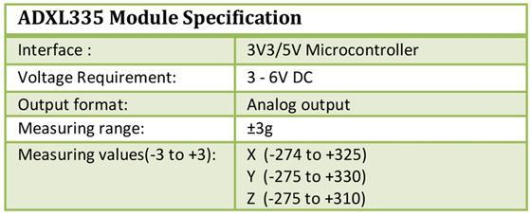

- PIN description of 3 Axis Accelerometer with Regulator – ADXL335
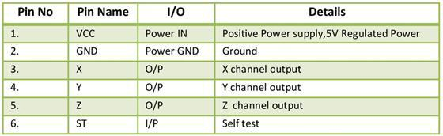
P a g e | 46

CHAPTER-5

FUTURE SCOPE

Can be used as Fire fighting robot to help people from fire accidents

The FFMR moves to the fire location and use five infrared sensors to detect fire event. If the fire event is true, the FFMR must fight the fire source using extinguisher. Whenever a flame gets detected by the robot, its motion will stop and the pumping mechanism of the robot gets turned on to extinguish the fire with the help of water. Robot will be able to detect flames coming out of fire if a fire blows up in or around its path.

APPLICATIONS
Can be used as a mobile surveillance system.

Can be used as a fire extinguisher at places out of human reach. Can be used in security system.

Can be used in chemical and oil industry, nuclear plants, mine fields and dangerous substance transport

For detecting fire with 100% accuracy so that the robot can differentiate between industrial fire and an ordinary flame, we will be adding three more type of sensors i.e. temperature sensor, smoke sensor and thermal sensor. To save people who get trapped in the fire, we will again use transmission of wireless signals to the fire fighting person so that they can easily locate the people and hence save a lot of precious time We can replace water in pumping system with pressurized carbon dioxide to¬ fight with fires caused due to electric short circuits. For domestic use, we will try to implement motion planning using neural¬ networks so that the errors can be minimized in mapping of the house.

- Range of “Rx” & “Tx ” can be increased
- It can be made voice controlled also

- Motor rpm can also be increased
- Eliminates the use of wires to control.

- Robust system, low power requirement.
- It is used in medical equipment as WHEEL-CHAIR for Handicap people.

6.Reference:

- www.engineersgarage.com
- Emtech foundation study material
- Ieeexplore.ieee.org
- http://www.alldatasheet.com
- www.sciencedirect.com

For Books:

1. PIC Microcontroller and Embedded system by Muhammad Ali Mazidi
- Interfacing with PIC Microcontroller by Martin Bates
- The Art of Programming Embedded System
P a g e | 47

